

**Question/Answer Booklet**

**Name:**

**PHYSICAL EDUCATION STUDIES**

**Yr 11 ATAR**

**Sports Psychology Test**

**Time allowed for this paper**

Working time for paper: 55 minutes

**Material required/recommended for this paper**

***To be provided by the supervisor***

This Question/Answer Booklet

|  |  |  |  |
| --- | --- | --- | --- |
| **Contents:**  Functional Anatomy | Multiple choice  Short answers  Extended question | 15 marks  45 marks  10 marks  **Total marks** | **/70** |

**Multiple Choice (15 marks)**

1. In tennis, prior to each service point, most players will use a performance routine. How does this help the player focus their attention on the serve?

1. Limits player distractions, such as the crowd and importance of the upcoming point
2. Regulates arousal levels in high pressure points
3. Identifies the task orientated ques for correct service technique
4. All of the above
5. The recent international summer Test Cricket Series between Australian and India was tarnished by on field sledging. Sledging is a term used in cricket to describe the practice whereby some players seek to gain an advantage by insulting or verbally intimidating the opposing player. Which mental skills strategy would best assist a player experiencing sledging whilst batting?

(a) Imagery

(b) Relaxation techniques

(c) Goal Setting

(d) Self-Talk

1. An NFL gridiron quarterback player deciding on tactics at the next line of scrimmage for the upcoming play would be an example of which area of attentional focus in Nideffer’s model ?
2. Broad-external.
3. Broad-internal.
4. Narrow-internal.
5. Narrow-external.

4. In a high pressure sporting situation, which of the following is not a physiological response to stress that an athlete would be likely to experience?

(a) increased adrenaline levels

(b) poor decision making

(c) muscular tension

(d) increased need to urinate

5. To give themselves the greatest chance of success, young athletes are advised to set goals that are;

(a) long-term and very challenging

(b) long-term and very achievable

(c) short-term and very challenging

(d) short-term and very achievable

6. Progressive Muscle Relaxation involves an athlete contracting a muscle for a short period of time, then releasing or relaxing. This type of relaxation would be best suited to:

(a) Decreasing anxiety before performing a soccer penalty kick.

(b) Increasing arousal before a soccer match.

(c) Increasing arousal before performing a soccer penalty kick.

(d) Decreasing anxiety before a soccer match.

7. The relationship between Ideal Performance State and athletic performance is best represented by:

(a) Bandura’s Model of Self Efficacy.

(b) Nideffer’s Model of Attention.

(c) Inverted-U hypothesis.

(d) Self-fulfilling prophecy.

8. Psychological skills training aims to match the needs of an individual performer but most programs have 3 phases which include;

(a) acquisition, conscious behaviour change and education

(b) education, practice and enhancement

(c) acquisition, conscious behaviour change and application

(d) education, acquisition and practice

9. Pressure is a term used to explain;

(a) anegative outlook – when things are not going as planned

(b) motivation to learn new skills or improve existing skills

(c) the natural stress response when demands increase

(d) why performance may not be at an expected level on a particular day

10. Which of the following is incorrect about imagery;

(a) the effectiveness of imagery will depend the task and the skill level of the performer

(b) imagery tends to be more applicable to open skills rather than closed skills

(c) imagery should be as real and controllable as possible

(d) imagery should involve as many of the senses as possible

11. Which of the following situations would require the performer to have a high level of arousal?

(a) a novice snooker player attempting to play a difficult shot into the corner

(b) a tennis player looking to establish a new serving technique

(c) a group of students in a tug-of-war match with other students

(d) playing a drop shot in badminton on match point

12. A coach who constantly criticises his athletes’ performance as a means of improving performance would be using:

(a) positive, intrinsic reinforcement

(b) negative, extrinsic reinforcement

(c) positive, extrinsic reinforcement

(d) negative, intrinsic reinforcement

13. The main purpose of having pre-competition strategies is:

(a) to make sure you have all the equipment needed for the game

(b) to be able to focus on the task relevant factors and to deny distractions from occurring before the event

(c) to relax before the game

(d) to make sure the coach knows what the player is doing before the performance.

14. A triathlete who imagines hand placement in the water to maximise stroke efficiency or, on the cycle leg talks themself through a controlled breathing exercise in order to reduce heightened anxiety, would be exhibiting:

(a) broad - external concentration

(b) narrow - external concentration

(c) narrow - internal concentration

(d) broad - internal concentration

15. Ensuring that progress is assessed against a standard or a previous performance is an example of which of the following aspects of goal setting?

(a) time phased

(b) realistic

(c) specific

(d) measurable

**Short Answer (45 marks)**

**Question 1 (2 marks)**

In terms of motivation, briefly describe **two (2)** differences you would expect to see between a young athlete and a mature/older athlete.

**Question 2 (3 marks)**

List three important characteristics of an athlete who is “in the zone”

A

**Question 3 (5 marks)**

Describe the difference between an outcome goal and a performance goal.

**Question 4 (6 marks)**

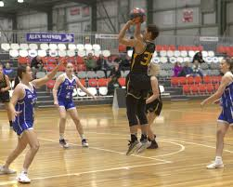James is a competent basketballer, currently playing in division 2, who would like to be playing in the top division team in her local competition. To achieve this, he will need to set some goals.

a). Describe 4 characteristics that goals should have in order to be effective. (4 marks)

g

b). Suggest 2 short term goals that James could set for himself (2 marks)

g

**Question 5 (3 marks)**

During periods of stress an athlete may experience an increase in heart rate and respiratory rate. Identify **three (3)** additional physiological changes an athlete could experience that may affect their performance.

**Question 6 (6 marks)**

1. Nideffer’s Model of Attention identifies four possible types of attentional focus.

**Width**

**Direction**

Label the figure below. (2 marks)

1. Provide a brief example for each of the four types of attentional control   
   in relation to tennis. (4 marks)

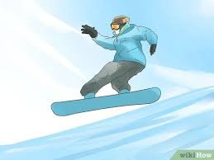**Question 7 (4 marks)**

Reece has been snowboarding for many years and is highly skilled in the sport. Earlier this year Reece had a bad fall as he attempted to land one of his more difficult tricks, a backflip. Previously, Reece was able to consistently land a backflip. However, since his fall he has been unsuccessful on each attempt. He realises that his inability to successfully perform this trick is due to a decrease in his self-confidence.

Discuss self-confidence and the impact it has on an athlete.

**Question 8 (6 marks)**

Describe each of the 3 stages of Psychology Skill Training (PST)

df

**Question 9 (6 marks)**

An individual’s concentration can be influenced by age, skill level and activity type. Describe how each of these factors impact concentration and for each factor, suggest one strategy the coach could use to help improve their concentration.

**Question 10 (4 marks)**

The Self-Efficacy Theory (Bandura, 1977) suggests that self-efficacy beliefs predict one’s behaviours, thought patterns and motivation.  Individuals with high self-efficacy will participate readily and more frequently, will put more effort in and persist longer, enhancing performance in sport and exercise (Bandura, 1986).

Explain 4 factors that can determine self-efficacy.

**Extended Answer (10 marks)**

**Question 1 (10 marks)**

Arousal levels during performance are an important component in sporting competitions. High jump competitors often have to wait for long periods of time between jumps, which can affect arousal regulation and performance levels.

Name and explain the relationship between arousal and performance, draw and label a diagram to support your discussion, indicating the point of optimal arousal for the high jumper.

**End of TEST**

**MARKING KEY**

**Multiple Choice (10 marks)**

|  |  |  |  |  |  |  |  |  |  |  |  |  |  |  |
| --- | --- | --- | --- | --- | --- | --- | --- | --- | --- | --- | --- | --- | --- | --- |
| 1 | 2 | 3 | 4 | 5 | 6 | 7 | 8 | 9 | 10 | 11 | 12 | 13 | 14 | 15 |
| d | d | b | b | d | d | c | d | d | b | c | b | b | c | d |

**Short Answer (45 marks)**

**Question 1 (2 marks)**

In terms of motivation, briefly describe **two (2)** differences you would expect to see between a young athlete and a mature/older athlete.

|  |  |
| --- | --- |
| Marks | Possible answer |
| 1 mark  1 mark | **Young athlete**   * Tend to be motivated by extrinsic rewards such as trophies/medals   **Mature/older athlete**   * Tend to be motivated by intrinsic factors such as performance. * May also be motivated by social factors |

**Question 2 (3 marks)**

List three important characteristics of an athlete who is “ïn the zone”

|  |  |
| --- | --- |
| Marks | Possible answers |
| 1 mark for each | * High quality of concentration * Emotional calmness * Alertness or readiness to perform * Positive feelings about performance (self-confidence) |

**Question 3 (5 marks)**

Describe the difference between an outcome goal and a performance goal.

|  |  |
| --- | --- |
| Marks | Possible answers |
| 1 mark per definition  3 marks to explain and/or provide example | * Outcome goal – focus on the outcome of the performance or competition * Examples win a game, finish on top of the ladder, win * Performance goal – specific target for performance to be achieved independently by an athlete in a team * Examples – take 10 rebounds in a game, serve 75% first serves in tennis, improve golf handicap   Difference - performance goals can be tailored to challenge individuals within a team and their successful completion will often result in the team achieved their outcome goal (ie. Winning) |

**Question 4 (6 marks)**

James is a competent basketballer, currently playing in division 2, who would like to be playing in the top division team in her local competition. To achieve this, he will need to set some goals.

a). Describe 4 characteristics that goals should have in order to be effective. (4 marks)

g

|  |  |
| --- | --- |
| Marks | Possible answers |
| 1 mark for each characteristic | Accurate explanation of 4 attributes of the goal setting acronyms (either SMARTER or SCCAMP) |

b). Suggest 2 short term goals that James could set for himself (2 marks)

g

|  |  |
| --- | --- |
| Marks | Possible answers |
| Max 2 marks | Appropriate short term goals – for example - improve particular aspects of fitness, attend training more regularly or higher level, act/implement feedback from coach, play/try a wider range of positions (1 mark for each answer) |

**Question 5 (3 marks)**

During periods of stress an athlete may experience an increase in heart rate and respiratory rate. Identify **three (3)** additional physiological changes an athlete could experience that may affect their performance.

|  |  |
| --- | --- |
| Marks | Possible answer |
| 1 mark each (max. 3) | * Increased body temperature, increased sweating/perspiration * Increased blood pressure * Increased blood supply to brain, heart, large muscles * Adrenalin secretion * Pupil dilation * Increase in muscle strength * Increase in muscle tension |

**Question 6 (6 marks)**

1. Nideffer’s Model of Attention identifies four possible types of attentional focus.

Label the figure below. (2 marks)

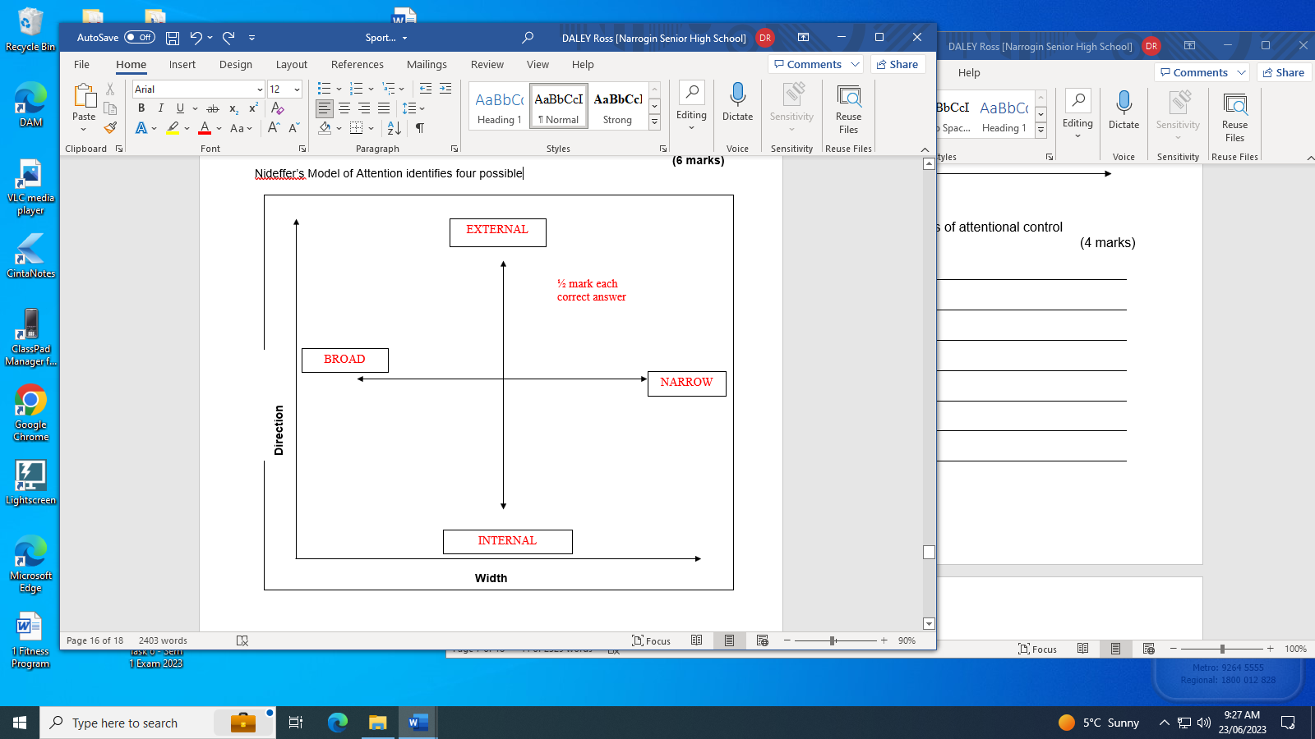

1. Provide a brief example for each of the four types of attentional control   
   in relation to tennis. (4 marks)

|  |  |
| --- | --- |
| Marks | Possible answer |
| 1 mark | **Broad-external**   * Being aware of opponent position and location of the ball (or other relevant example) |
| 1 mark | **Broad-internal**   * Game strategies and tactics (or other relevant example) |
| 1 mark | **Narrow-external**   * Receiving a serve (or other relevant example) |
| 1 mark | **Narrow-internal**   * Focus on a specific coaching point (or other relevant example) |

**Question 7 (4 marks)**

Discuss self-confidence and the impact it has on an athlete.

|  |  |
| --- | --- |
| Marks | Possible answer |
| 1 mark | Definition of self confidence:   * Self-confidence is the belief in ones own self that they can successfully perform a desired outcome. |
| 3 mark max | Impact of self confidence (any three):  Having good levels of self confidence leads to:  Positive thoughts/emotions  Increased motivation to learn  Better focus on goals  Having low self confidence can lead to:  Doubt in ones own ability  Negative thoughts  Expectation of failure leading to actual failure  Being over confident can lead to:  Inadequate preparation due to expectation of success  Low motivation and/or arousal |

**Question 8 (6 marks)**

Describe each of the 3 stages of Psychology Skill Training (PST)

df

|  |  |
| --- | --- |
| Marks | Possible answer |
| 1 mark for identification  1 mark for description | **1. Education Phase**  Players are made aware of what psychological skills are and how they could benefit and improve their performances by using them.  **2. Acquisition Phase**  Players determine what specific psychological skills would benefit them and when, why and how they would use them.  **3. Practice Phase**  The necessary mental skills are regularly practiced until the player can use them without conscious thought in a game. Application of mental skills becomes an automated response when needed. |

**Question 9 (6 marks)**

An individual’s concentration can be influenced by age, skill level and activity type.

|  |  |
| --- | --- |
| Description | Marks |
| Age:   * Typically, the younger the individual, the more likely they are to lose focus on a regular basis * Reduce length of drills, increase variety amongst activities and training sessions   Other relevant example | 1 mark for description  1 mark for strategy |
| Skill Level:   * Highly skilled athletes are better able to attend to relevant stimuli whilst ignoring distractions * As a result, when coaching less skilled participants, coaches must provide more predictable, closed environments, allowing the players to focus on a reduced number of stimuli * As the players become more skilled, the environment can become more open, allowing the individuals to develop the ability to filter out distractions whilst also shifting their attention from one stimulus to the next.     Other relevant example | 1 mark for description  1 mark for strategy |
| Influence of activity type   * Activities that provide constantly changing stimuli are more likely to maintain the attention and focus of an individual * This is further enhanced by whether an individual finds the task enjoyable   Other relevant example | 1 mark for description  1 mark for strategy |

**Question 10 (4 marks)**

Explain 4 factors that can determine self-efficacy.

|  |  |
| --- | --- |
| Marks | Possible answer |
| 1 mark for description | **Performance outcomes**  Positive and negative experiences can influence the ability of an individual to perform a given task. If one has performed well at a task previously, he or she is more likely to feel competent and perform well at a similarly associated task.  **Verbal Persuasion**  Self-efficacy is influenced by encouragement and discouragement pertaining to an individual’s performance or ability to perform.  **Vicarious Experiences**  People can develop high or low self-efficacy vicariously through other people’s performances. A person can watch another perform and then competence their own competence with others competence.  **Physiological Feedback**  People experience sensations from their body and how they perceive this emotional arousal influences their beliefs of efficacy |

**Extended Answer (10 marks)**

Name and explain the relationship between arousal and performance, draw and label a diagram to support your discussion, indicating the point of optimal arousal for the high jumper.

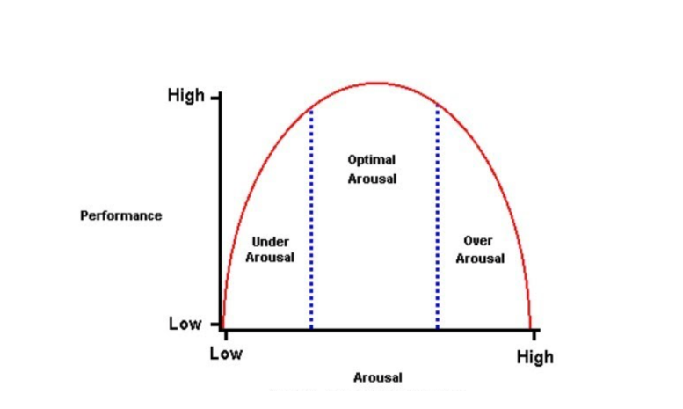

|  |  |
| --- | --- |
| Marks | Possible answer |
| 1 mark for naming  Max 4 marks for diagram  2 marks for under arousal and over arousal  1 mark for optimal arousal | Identify:  Inverted U Hypothesis  1 mark - Performance must be Y axis  1 marks - Arousal must be X axis  1 mark – Drawn arousal curve (even)  1 mark – Labelling point of optimal arousal  Under aroused - performance will be less than optimal and attention being given to irrelevant cues and a lack of concentration.  Over-arousal with the corresponding drop in performance due to increased muscular tension and the missing of important cues in the environment.  Optimal arousal level corresponding with optimal performance level |